9.97: Introduce the auxiliary variable L, the length of the cylinder, and consider thin cylindrical shells of thickness dr and radius r; the cross-sectional area of such a shell is 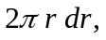 and the mass of shell is 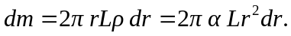 The total mass of the cylinder is then
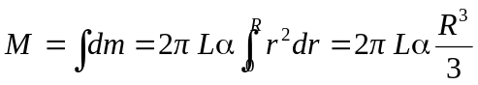
and the moment of inertia is
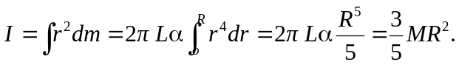
b) This is less than the moment of inertia if all the mass were concentrated at the edge, as with a thin shell with 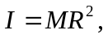 and is greater than that for a uniform cylinder with 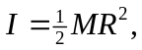 as expected.

